CPAN 212 Lab 8-9 Report
By: Abdulhamid Weheliye

Lab Objective
To teach students how to implement a secure full-stack insurance platform through the software development model of a real business. Utilizing HTTPS for sensitive communication. User authentication via JWT. Protecting RESTful APIs from unauthorized access and ensuring users can only access data and actions allowed by their role. And ensuring that RBAC rules are managed by the administrator through the application.

Architecture Overview
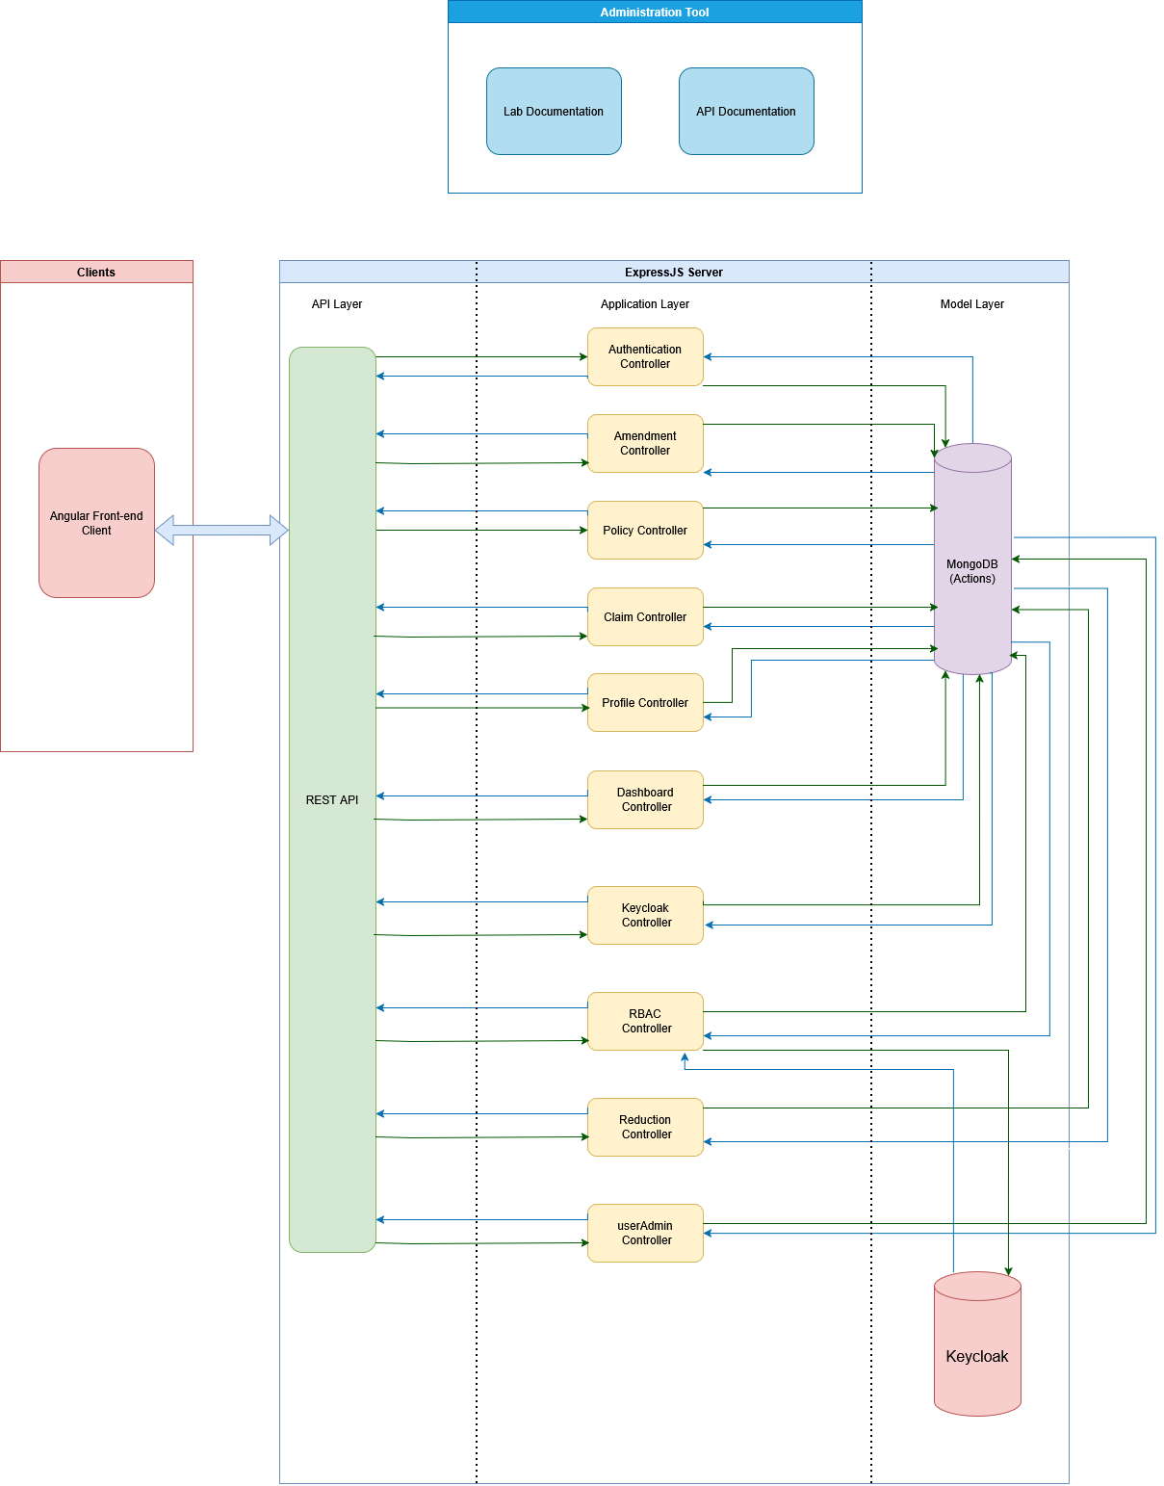

Authentication Workflow
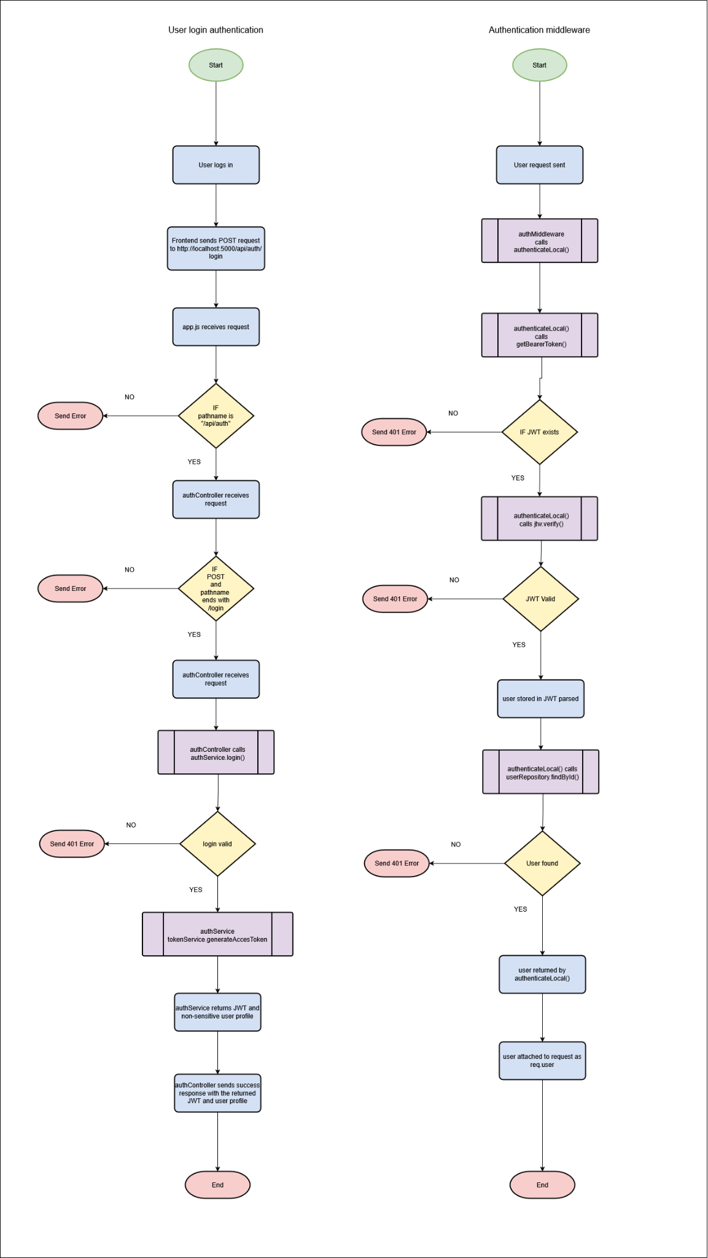

Authorization Workflow
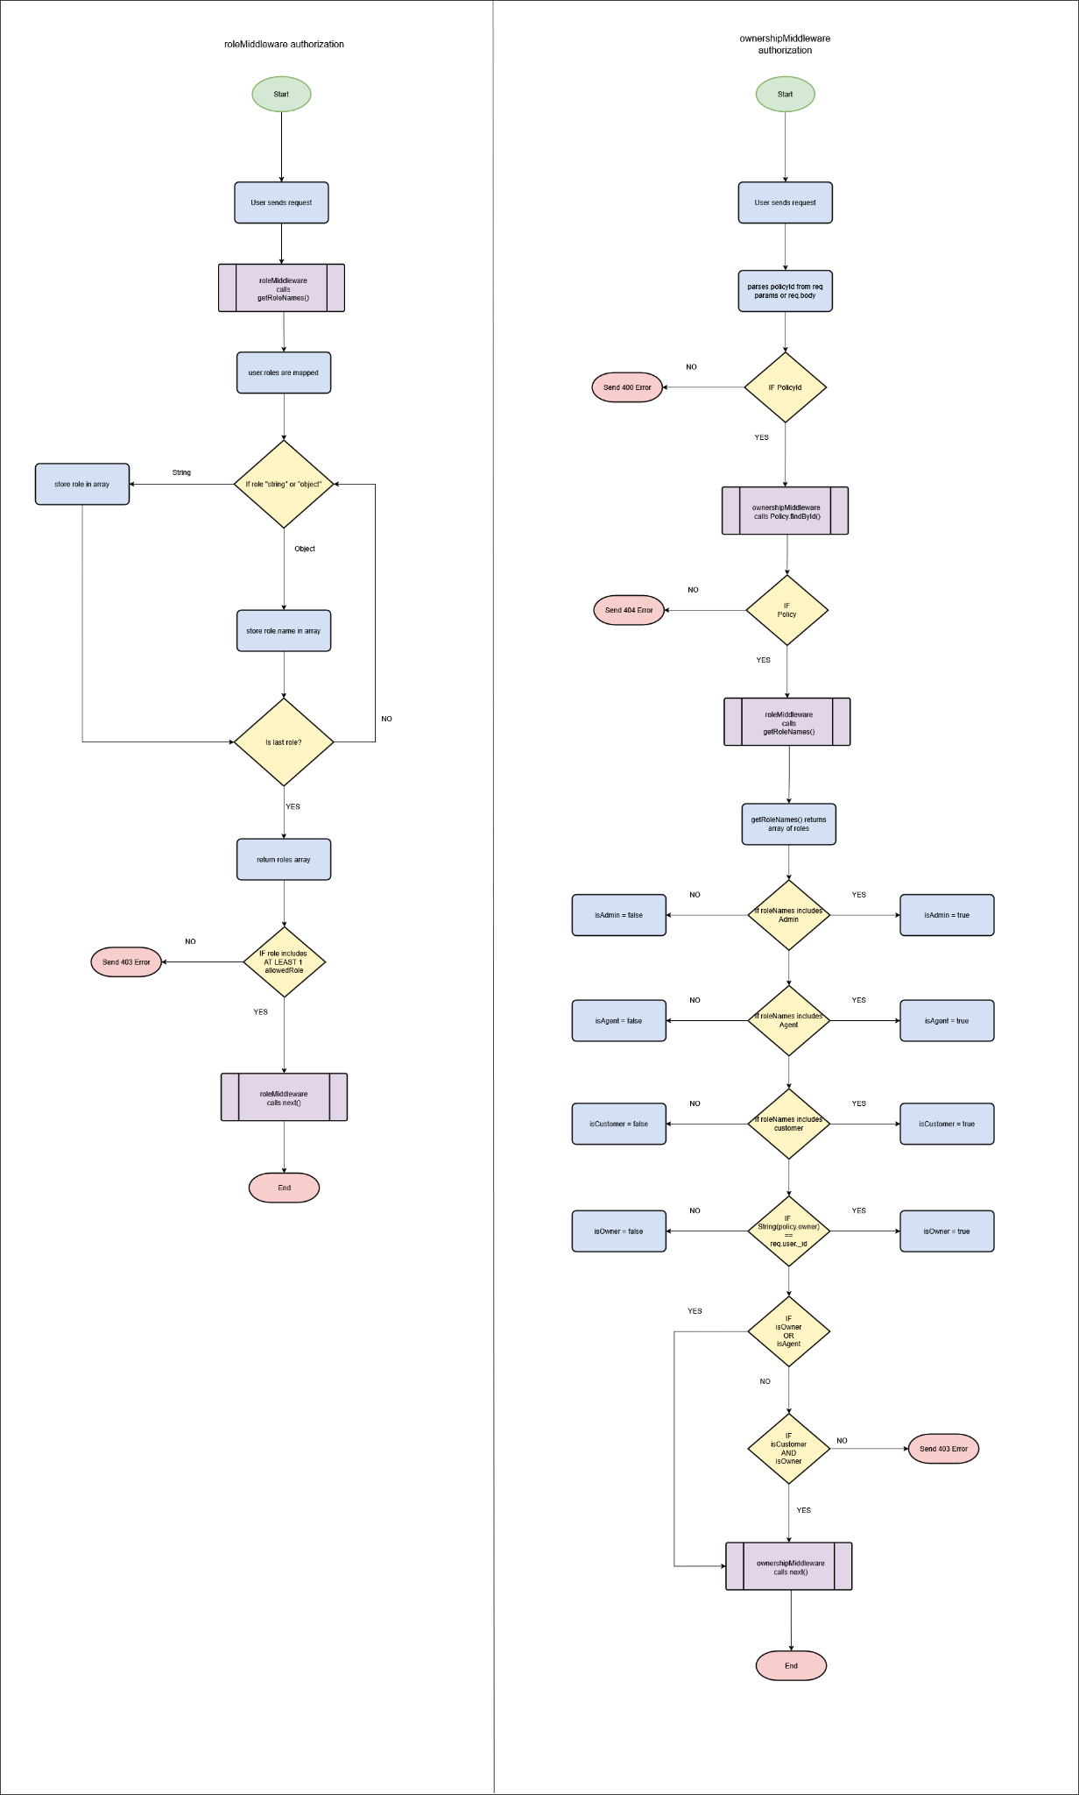

User Profile Design Explanation
User profiles have two logical layers:
- The authentication layer
  - userId
  - Username
  - Password
  - Account status
  - Roles
- The Business profile layer
  - userId
  - First name
  - Last name
  - DOB
  - Email
  - Phone number
  - Address line 1
  - Address line 2
  - City
  - Postal code
  - Country
  - Customer number or employee number
  - User type
  - Preferred contact method
  - Emergency contact name
  - Emergency contact phone
  - Status
  - createdAt
  - updatedAt

For internal users the user profile also supports:
- Department
- Job title
- Supervisor name/id
- Internal access status
For customers:
- Client category
- Linked policies cont/references
- Beneficiary-related field placeholder for life insurance (if needed)

RBAC Management By Admin
Admins can currently only view a list of users and view their own profile.

HTTPS Configuration
A pfx certificate is placed inside a certificates folder. The path and passphrase for the pfx is configured in the .env file. In a config file called https.js, you create a method to read the pfx and return both the pfx and its passphrase.

In the server https is currently not configured.

To configure HTTPS In the server.js you would create an httpsServer by using https.createServer() method and you pass the method from https.js to configure the server.

